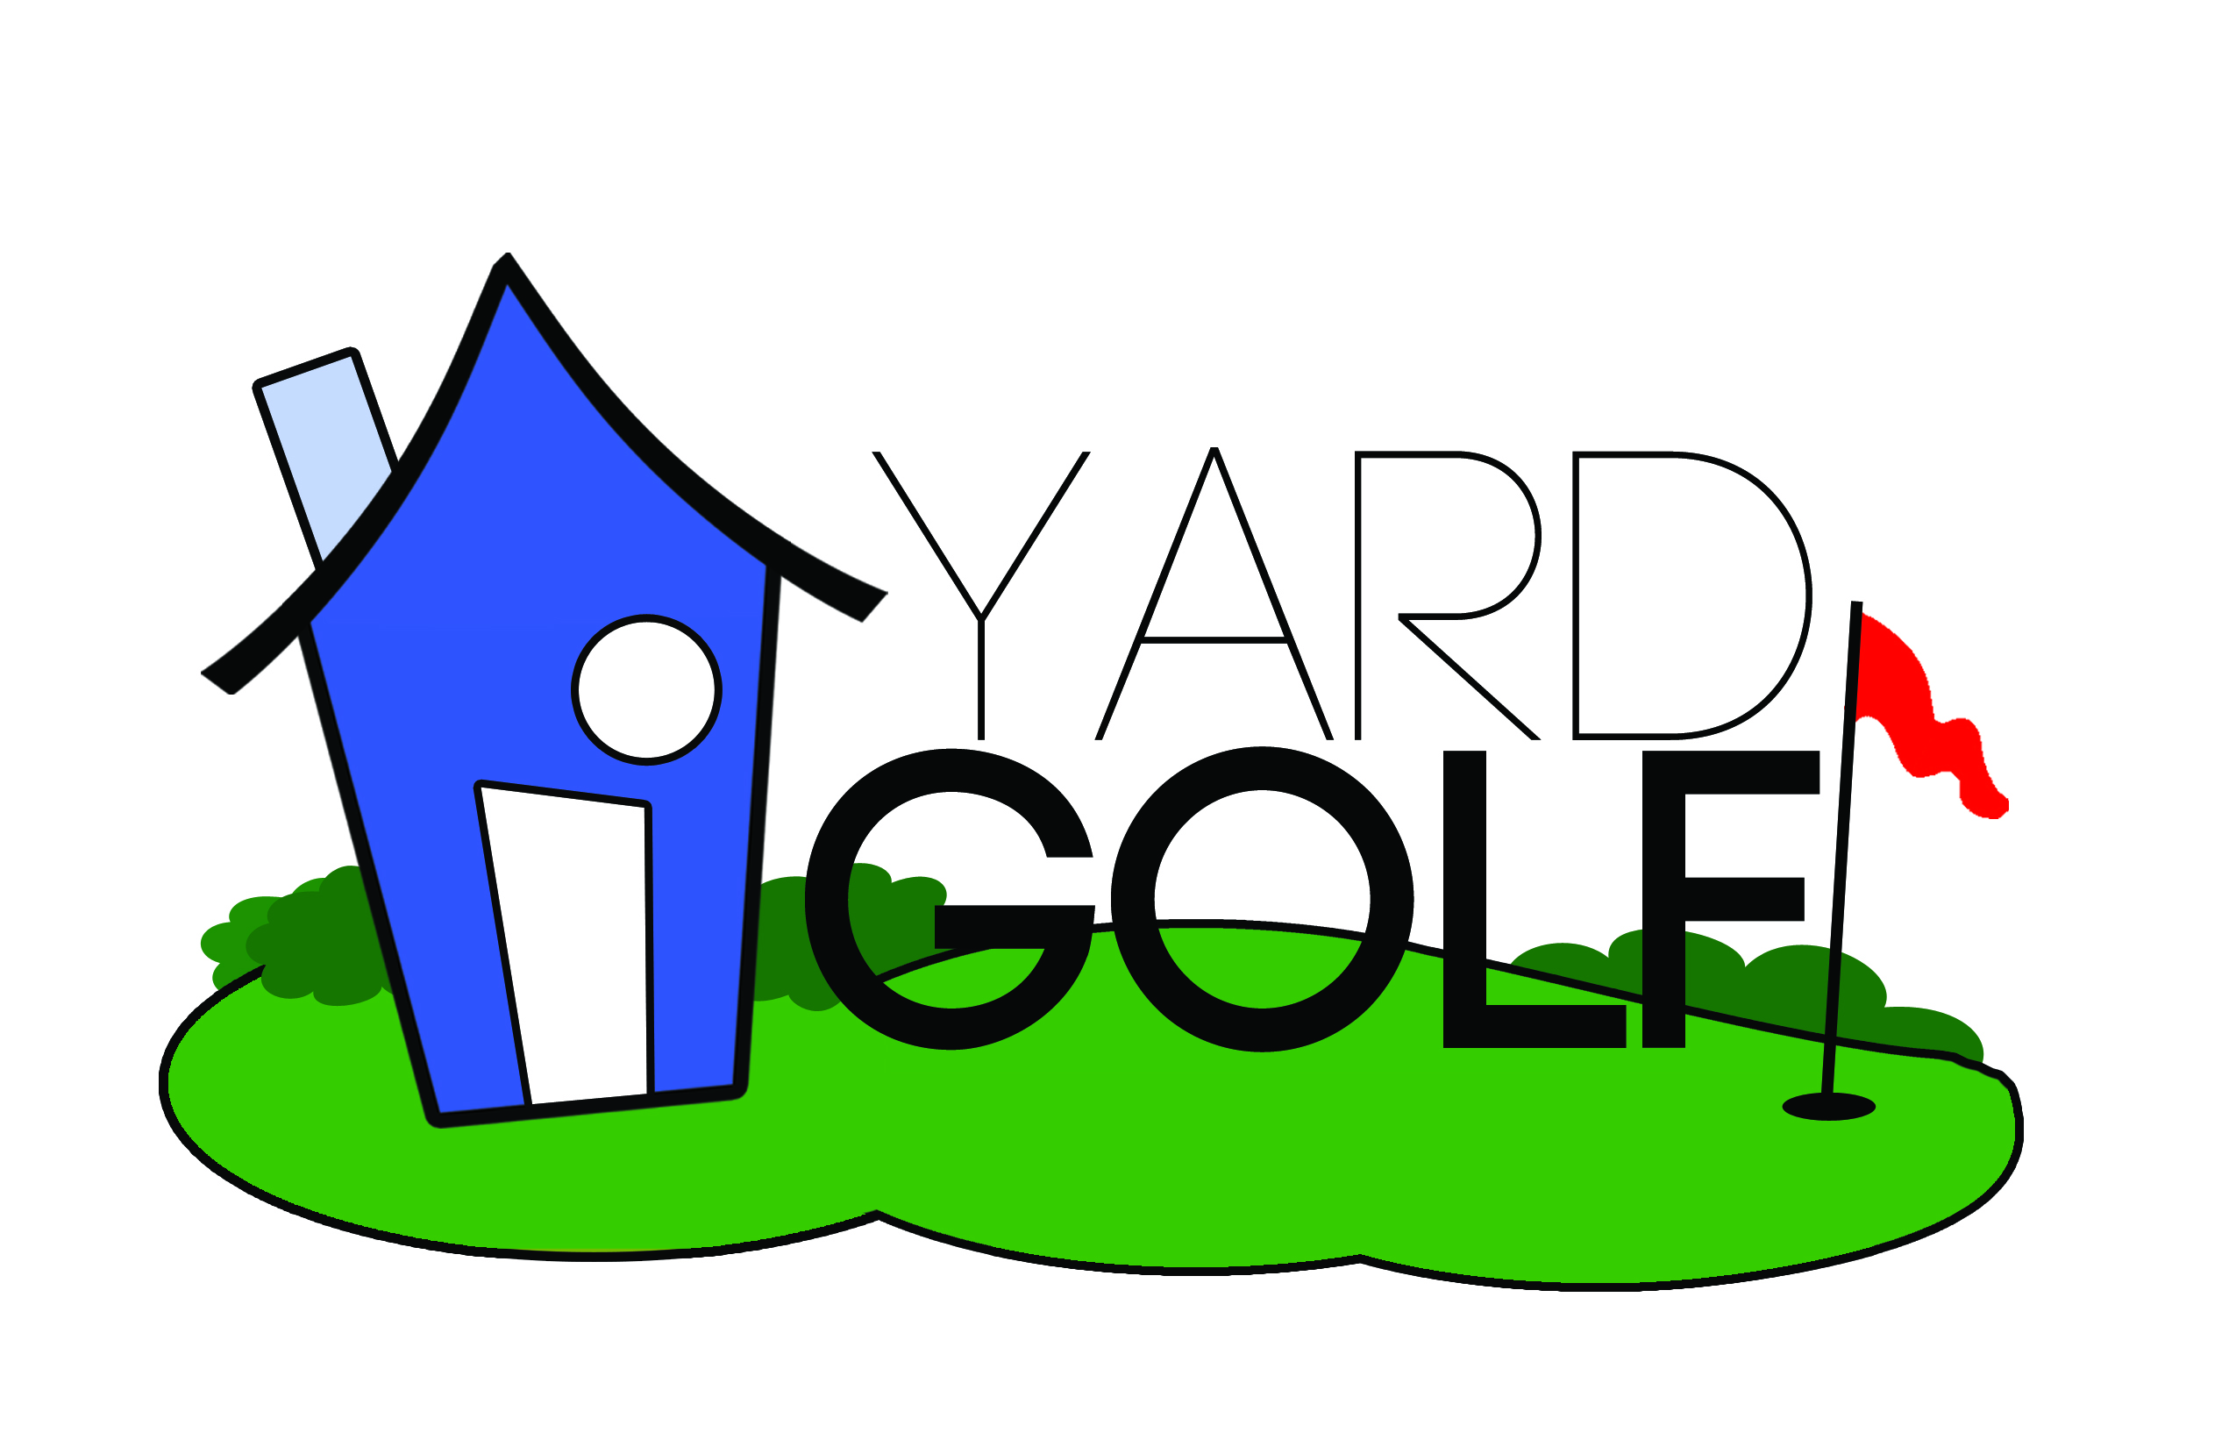
Here's how YARD GOLF works:
- It's real simple, you can play YARD GOLF by yourself or with family and friends; either will work.
- Everyone gets 1 club (a wedge of some sort) and 1 ball.
- Start in the yard and have the first player pick out a YARD GOLF hole for everyone to complete.
- Once the YARD GOLF hole has been identified everyone will take turns hitting their own ball until it touches the final target (which could be a tree, bush, drain cover, fence post, sprinkler head, fire hydrant, or any other regular object). Then the hole is complete.
- Play as many or as few YARD GOLF holes as you want to and keep score.
- The object of YARD GOLF is to have the lowest total score in the group after all the holes have been played.
Want to make YARD GOLF more fun and challenging?
- Try creating YARD GOLF holes that have different score for par (3, 4, or 5; you could even get a little crazy and design a par 6, 7, or 8…It's up to you!!!)
- Make YARD GOLF holes that bend/dogleg left or right. See our sample course map for ideas.
- Create YARD GOLF holes with real and imaginary obstacles like trees, bunkers, water hazards, castles, volcanoes and anything else you can think of.
- Play YARD GOLF using different formats like: stroke play, match play, family challenge, team vs. team, etc...
- Make a real YARD GOLF scorecard and use tees and ball markers while you play.
- Host a YARD GOLF tournament with all the kids in the neighborhood!
- Play YARD GOLF dressed as your favorite PGA Tour player. Maybe Rickie Fowler or Bubba Watson?
Remember:
- Always ask your parents for permission before playing YARD GOLF.
- Never pick a YARD GOLF hole by a window or other valuable property (ex: automobiles).
- Play YARD GOLF in your own yard.
- Be gentle on the grass and all other surfaces that you may find yourself playing YARD GOLF from.
- Follow The First Tee Code of Conduct when playing YARD GOLF: Respect for Myself, Respect for Others, and Respect for my Surroundings.
Parents:
- Play YARD GOLF with your kids until they are ready to do it on their own
- Make sure kids are only using wedges and not long irons or woods to play YARD GOLF.
- If your child is not ready to use a real golf ball, you can find SOFTER practice balls at most retail stores. The perfect YARD GOLF ball is from Almost Golf and is sold at Golf Galaxy and Dick's Sporting Goods!

SAMPLE COURSE MAP

